**ACHIEVEMENT PROGRAM**

**GOLDEN SPIKE AWARD**

**APPLICATION FORM**

**JANUARY 2025**

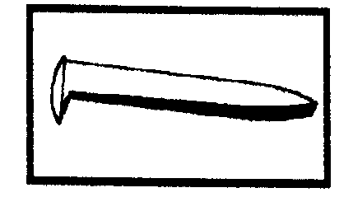

PLEASE COMPLETE THIS APPLICATION FORM AND SEND TO YOUR DIVISION OR REGION AP MANAGER

Member Name: __________________________________ NMRA #: _____________ Exp: _________________

Street: __________________________________________ City: _____________________ State/Prov.: _______

ZIP/PC: _______________ Country: ________________ NMRA Region: ______________ Division: _________

Date Submitted: ___________________ E-Mail: __________________________ Phone: ___________________

* The Golden Spike Award (GSA) will be awarded to any NMRA member who completes the Qualifications Checklist, obtains the necessary signatures (Division AP Manager or some local NMRA member approved by the Division AP Manager), and if the applicant does not already hold MMR status.
* The GSA will be administered by the Division and Region AP Managers.
* AP reguirements and definitions apply for scratch building and super-detailing.
* The Division AP Manager will submit the signed form to the Region AP Manager who will issue the Golden Spike Award certificate.
* The Region AP Manager will then forward the completed form to the National AP Manager so that an announcement can be made in the NMRA Magazine.

**GOLDEN SPIKE AWARD QUALIFICATIONS CHECKLIST:**

**1. Rolling Stock (Motive Power & Cars):**

Display six units of rolling stock either scratchbuilt, craftsman kits or superdetailed commercial kits.

**2. Model Railroad Setting (Structures & Scenery**

Construct a minimum of eight square feet of model railroad or module(s) including scenery in any scale.

Construct five structures either scratchbuilt, craftsman kits or superdetailed commercial kits. If a

module has less than five structures, additional structures separate from the scene may be presented.

**3. Engineering (Civil & Electrica****l)**

Three types of track are required (e.g. turnout, crossing, crossover, etc.). All must be properly

ballasted and installed on proper roadbed. Commercial track may be used.

All installed track must be properly wired so that two trains can be operated simultaneously

(e.g. double track main, single track main with sidings, and block or command or other form of control).

Provide any one additional electrical feature such as power operated turnouts, signaling, turnout

indication, lighted buildings, etc.

**Witness:** ________________________ Name**:** ______________________ **NMRA #:** __________

**Region AP Manager:** ________________________________________ **Region:** _______________