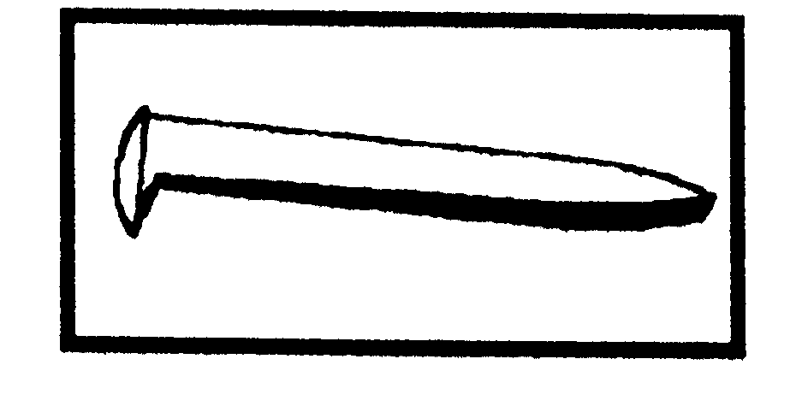
ACHIEVEMENT PROGRAM
GOLDEN SPIKE AWARD
APPLICATION FORM
May 2006
PLEASE COMPLETE THIS APPLICATION FORM AND SEND TO YOUR REGIONAL OR DIVISIONAL AP CHAIR

Member's Name: ______________________________NMRA#: ______________EXP: ____________

Address: ________________________________________________ City: ______________________

State/Prov: ________________Country: ________________________Postal Code: _______________

Date Submitted: __________________ Region: _______________________________________

The Golden Spike Award will be awarded to any NMRA member who has completed the Qualifications Checklist, obtained the necessary signatures and who does not hold MMR status. It will be administered by the regional and divisional AP Chairs. AP regulations and definitions apply for scratchbuilding and superdetailing. To qualify for the award the member must complete the following checklist, obtain the signature of the divisional AP Chair or another NMRA member designated by the divisional Chair. The divisional Chair will submit the signed form to the regional AP Chair who will issue the Golden Spike Award certificate.

QUALIFICATIONS CHECKLIST:

1. Rolling Stock (Motive Power & Cars):

Display six units of rolling stock either scratchbuilt, craftsman kits or super-detailed commercial kits.

2. Model Railroad Setting (Structures & Scenery)

Construct a minimum of eight square feet of layout including scenery.
Construct five structures either scratchbuilt, craftsman kits or superdetailed commercial kits. If a
module has less than five structures, additional structures separate from the scene may be presented.

3. Engineering (Civil & Electrical)

Three types of trackage required (e.g. turnout, crossing, crossover, etc.). All must be properly
ballasted and installed on proper roadbed. Commercial trackage may be used.
All installed trackage must be properly wired so that two trains can be operated simultaneously
(e.g. double track main, single track main with sidings, and block or command control).
Provide one additional electrical feature such as power operated turnouts, signaling, turnout
indication, lighted buildings, etc.

Witness: ________________________ Name: ______________________ NMRA #: __________

Regional AP Chair: ________________________________________ Region: _______________

